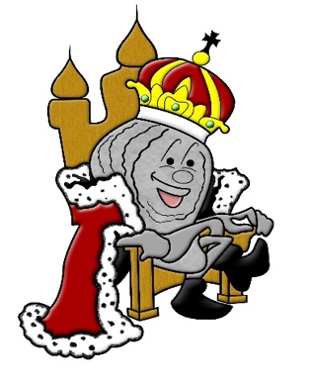

2020 OYSTER FESTIVAL

SPONSORSHIP AGREEMENT

When you agree to become an Oyster Festival Sponsor, you can feel good in the knowledge that you are partnering with Rotary International and helping fund scholarships & programs for youth, fight the war on polio, feed the less fortunate, and assist over 30 charitable endeavors, locally and globally.

This contract between ___ and The US Oyster Festival, representative of the Rotary Club of Lexington Park, is for inclusion as a sponsor for the 2020 US Oyster Festival at the level indicated below.

Sponsorship Opportunities

_________ Platinum Sponsor: $ 2,000

_________ Gold Sponsor: $ 1,500

_________ Silver Sponsor: $ 1,000

__________ Bronze Sponsor $ 500

__________ Friend of the Festival $ 100

__________ Other mount $ __________

______________________________________
Sponsor Contact Signature Sponsor Contact Printed Name

Sponsor Corporate Name

__________________________________________________________________________________________________
Business Mailing Address (Street or PO Box, City, State, Zip Code)

__________________________
Contact Email Address Contact Phone Number

Thank you for your support!

Please complete this form and return, with payment, by August 31st to the address below.
Please make checks payable to The Rotary Foundation of Lexington Park.
Please send an electronic version of your logo to Karen Stone at usoysterfestival@gmail.com.

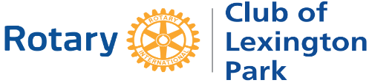
U.S. Oyster Festival in St. Mary’s County, MD
P.O. Box 766 | California, MD 20619
301-863-5015 | usoysterfestival@gmail.com

