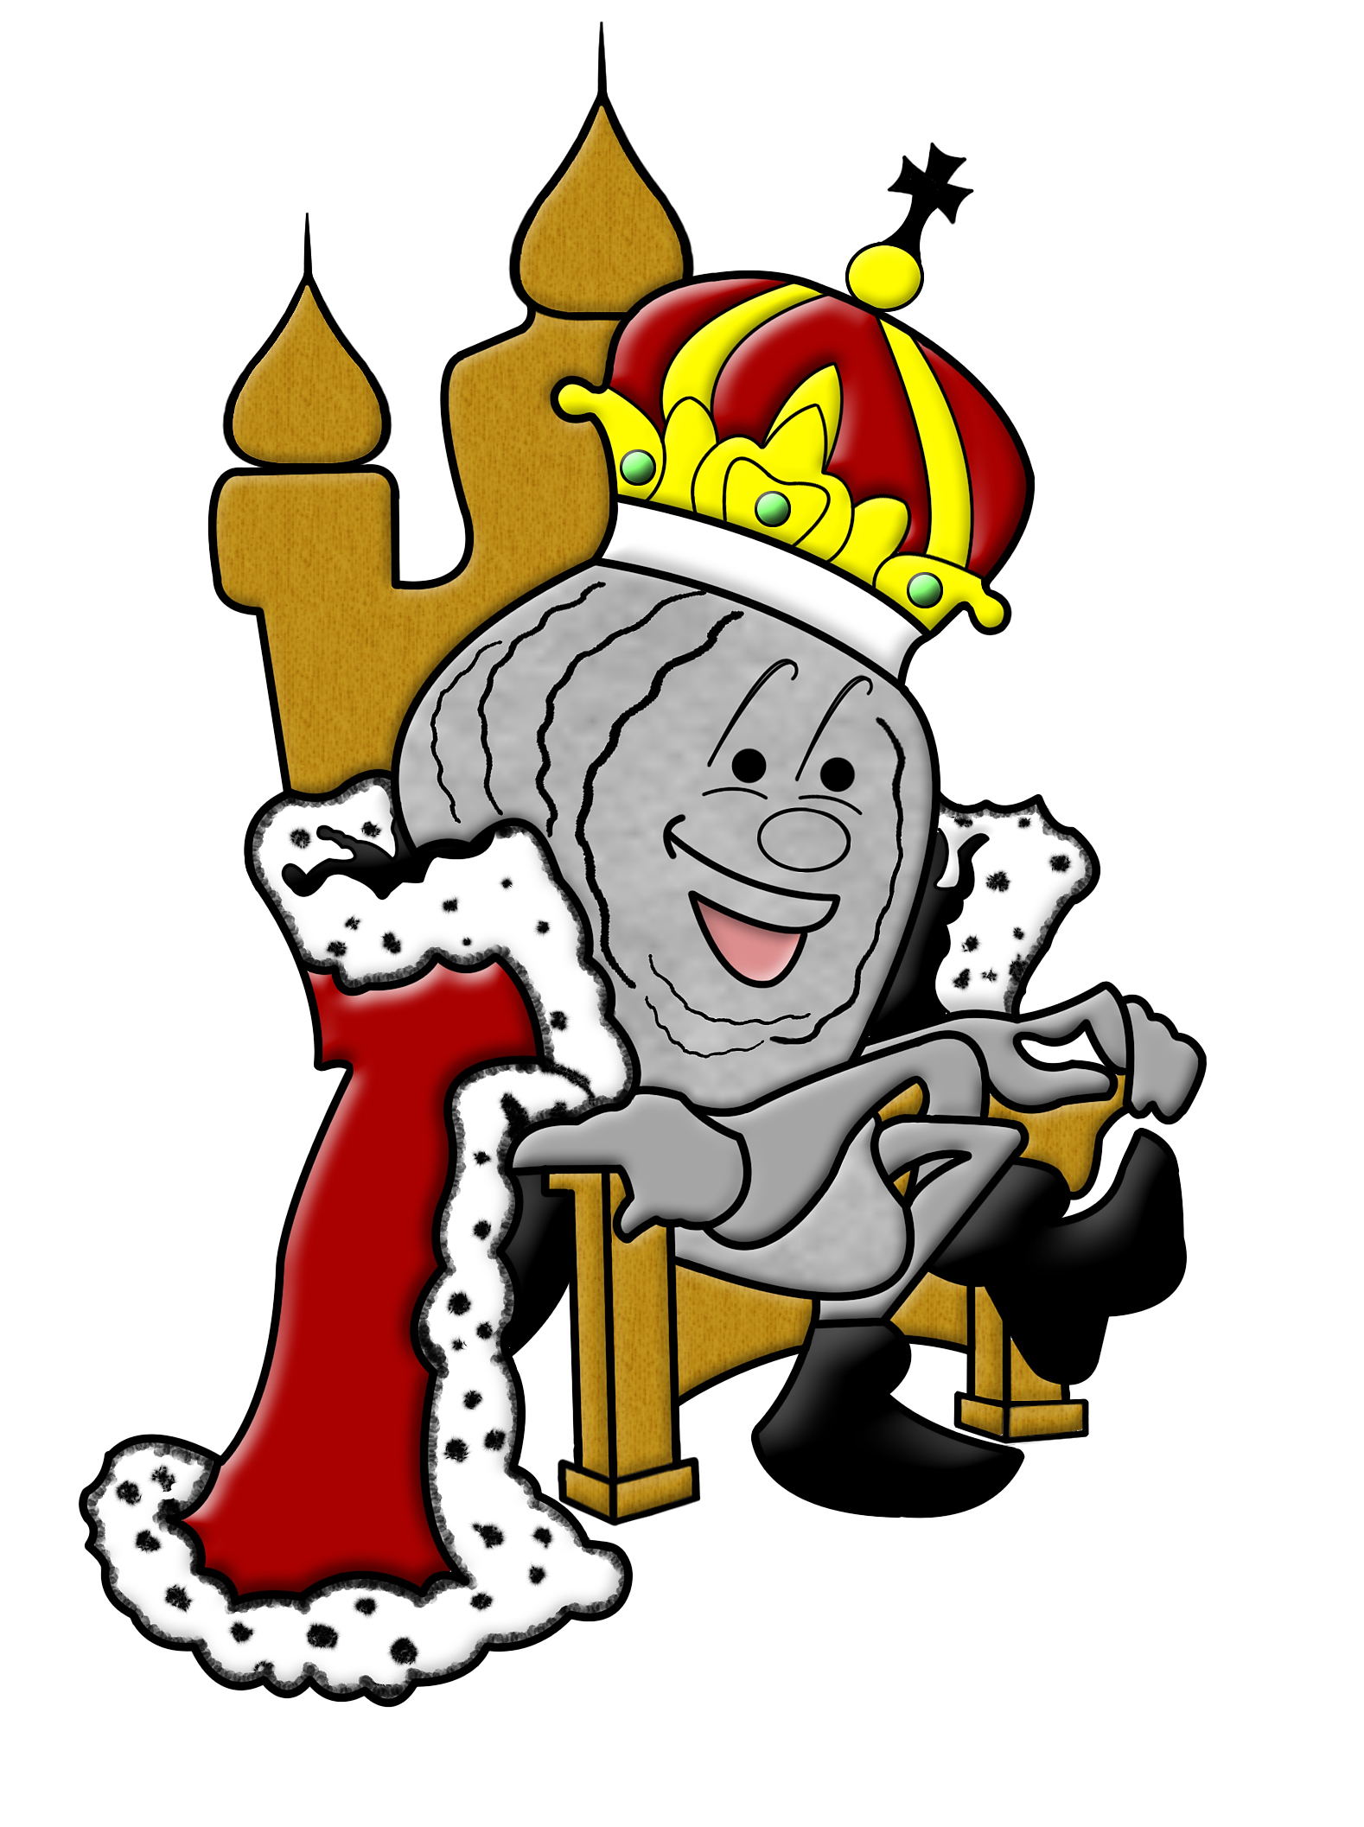

2023 US OYSTER FESTIVAL

SPONSORSHIP AGREEMENT

When you agree to become an Oyster Festival Sponsor, you can feel good in the knowledge that you are partnering with Rotary International and helping fund their many scholarships & programs for youth, fight the war on polio, feed the less fortunate, and assist over 30 charitable endeavors, locally and globally.

This contract between ___ and The US Oyster Festival, representative of the Rotary Club of Lexington Park, is for inclusion as a sponsor of the 2023 US Oyster Festival at the level indicated below.

Sponsorship Opportunities

_________ Platinum Sponsor: $ 5,000

_________ President’s Circle: $ 2,500

_________ Director’s Circle $ 1,000

_________ (Individuals) Friend: $ 250

______________________________________
Sponsor Contact Signature Sponsor Contact Printed Name

Sponsor Corporate Name

__________________________________________________________________________________________________
Business Mailing Address (Street or PO Box, City, State, Zip Code)

__________________________
Contact Email Address Contact Phone Number

Thank you for your support!

Please complete this form and return, with payment, by August 31st to the address below.
Please make checks payable to The Lexington Park Rotary Foundation.

Please send an electronic version of your logo to Karen Stone at usoysterfestival@gmail.com.

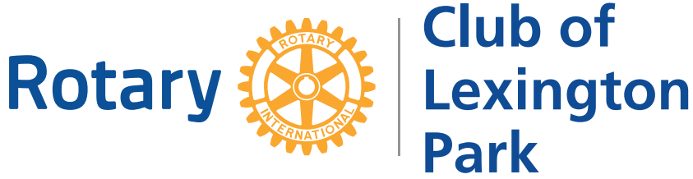
U.S. Oyster Festival in St. Mary’s County, MD
P.O. Box 766 | California, MD 20619
301-863-5015 | usoysterfestival@gmail.com

